Type the title of your paper here
The Paper Title 每个实词首字母大写
List the author names here
San Zhang^{1[ORCID]}, Si Li^{2[ORCID]}, Wu Wang^{3*[ORCID]}
Type the author addresses here
¹ Suzhou Nuclear Power Research Institute, Suzhou, Jiangsu Province, 215004, PR
China
² Shanghai Minghua Power Technology Co., Ltd., NO. 1687 Changyang Rd, Shanghai
200090, P.R. China
³ CHN Energy New Energy Technology Research Institute Co., Ltd., Future
Technology City, Beijing 102209, P.R. China
Type the corresponding author’s e-mail address here
*Corresponding author’s e-mail: 强烈建议使用机构邮箱
Abstract. Start your abstract here…
- The first section in your paper
The first paragraph after a heading is not indented (Bodytext style).
Other paragraphs are indented (BodytextIndented style).
- Another section of your paper
The first paragraph after a heading is not indented (Bodytext style).
Other paragraphs are indented (BodytextIndented style).

A subsection
Some text.
    - A subsubsection. The paragraph text follows on from the subsubsection heading but should not be in italic.

图片——居中，嵌入型，要清晰，图释放在下面
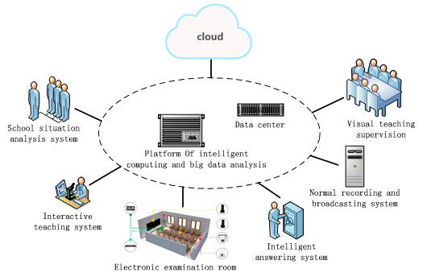
Figure 1. This is a picture for example

表格——标题在上面；表格不要超出版面
Table 1. PT results and acceptance criteria
 | Font | Spacing
Section | 11 point Times bold | 1 line space before a section  No additional space after a section heading
Subsection | 11 point Times Italic | 1 line space before a subsection  No space after a subsubsection heading
Subsubsection | 11 point Times Italic | Subsubsections should end with a full stop (period) and run into the text of the paragraph

公式——居中，序号在右侧；所有公式按顺序编号
$\begin{aligned}V_{o}=\frac{\sum_{i=0}^{n}{M_{i}F_{i}}}{\sum_{i=0}^{n}{M_{i}}}\end{aligned}$ (1)
Acknowledgments
致谢/项目基金必须放在参考文献前面
References
- A reference
This reference has two entries but the second one is not numbered (it uses the ‘Reference (no number)’ style.
- Another reference
- More references

示范：

- Sze S M 1969 Physics of Semiconductor Devices (New York: Wiley–Interscience)
- Dorman L I 1975 Variations of Galactic Cosmic Rays (Moscow: Moscow State University Press) p 103
- Caplar R and Kulisic P 1973 Proc. Int. Conf. on Nuclear Physics (Munich) vol 1 (Amsterdam: North-Holland/American Elsevier) p 517
- Szytula A and Leciejewicz J 1989 Handbook on the Physics and Chemistry of Rare Earths vol 12, ed K A Gschneidner Jr and L Erwin (Amsterdam: Elsevier) p 133
- Kuhn T 1998 Density matrix theory of coherent ultrafast dynamics Theory of Transport Properties of Semiconductor Nanostructures (Electronic Materials vol 4) ed E Schöll (London: Chapman and Hall) chapter 6 pp 173–214

写作建议（论文不得少于4页）文献总数需要在4个或以上
论文不能出现社会经济类（ socio-economic） 相关内容； 禁止出现中文字符

页眉页脚：全文中不能有页码，页眉，页脚出现。
内容：注意检查语法错误，语言表达；全文中，包括图表中禁止出现中文。（除研究需要中文文字图片，例如文字图像研究等等。）

投稿须知：过于简短的海报论文或摘要论文（1-2页）不会被录用；论文应至少4-5页; 作者可通过CrossCheck, Turnitin或其他查询体统自费查重，否则由文章重复率引起的被拒搞将由作者自行承担责任。涉嫌抄袭的论文将不被出版。

